Authorization ForM

Blessed Sacrament Church

FOR OFFICE USE ONLY |  |  |  | ENVELOPE/DONOR # |  |  |  | DATE
Effective date of authorization: _____/_____/_____

Type of authorization: |  | - New authorization |  |  | - Change donation amount |  |  |  |  | - Change donation date
 |  | - Change banking information |  |  | - Discontinue electronic donation
Last Name |  |  |  |  |  | First Name

Address
City |  |  |  |  |  |  |  |  | State |  |  | Zip

Email Address
DATE OF FIRST DONATION:  _______/_______/_______ |  |  | FREQUENCY OF DONATION:  - Monthly on the 1st  - Monthly on the 10th  - Monthly on the 20th |  |  |  | FUNDS:  - Sunday Offering  - General Maintenance Acct.  - New Facilities Fund  - St. Vincent de Paul Society  - New Facilities Phase 2  Total |  |  |  | AMOUNTS:  $_____________  $_____________  $_____________  $_____________  $_____________  $_____________
 | Please debit my donation from my (check one):  - Savings Account (contact your financial institution for Routing #)  - Checking Account (attach a voided check below) |  |  |  |  |  | Routing Number: ____________________________  Valid Routing # must start with 0, 1, 2, or 3  Account Number: ____________________________  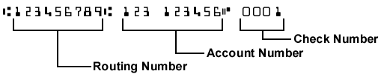
I authorize the above organization to process debit entries to my account. I understand that this authority will remain in effect until I provide reasonable notification to terminate the authorization.

Authorized Signature:_______________________________________________________ Date:________________

If using a checking account, please attach a voided check at the bottom of this page.

